In partial fulfillment of the requirements for the

ITE121 – Intermediate Programming

**“Mathematical Calculator”**

Presented to:

Dr. Unife O. Cagas

Professor

Prepared by:

Richelle Mae S. Gipala

BSCS – 1B2

May 2, 2024

**INTRODUCTION**

This project is a Calculator that can calculate basic logical calculation. I use a python code to implement the graphic user interface (GUI) using the Tkinter. The calculator can perform arithmetic operations such as addition, subtraction, multiplication, and division, as well as advanced functions like square root, sine, and cosine. The GUI layout is designed to be user-friendly, with buttons for each operation and function arranged in a grid pattern. Error handling is also included to manage exceptions and display error messages when necessary.

* 1. **OBJECTIVE**
* To create a scientific calculator, the code uses the Tkinter library in Python for the graphical user interface (GUI).
* To perform arithmetic operations, the calculator includes functions for addition, subtraction, multiplication, and division.
* To provide advanced mathematical functions, the code implements operations such as square root, sine, and cosine.
* To ensure user-friendly interaction, the GUI layout is designed with clear button labels and an organized grid pattern.
* To handle errors gracefully, the code includes error-catching mechanisms to display informative messages to the user.
* To achieve the objective of creating a functional and user-friendly calculator, the code combines the implementation of mathematical operations, GUI design, and error handling.
  1. **SIGNIFICANCE**

This project is produced with this Python code represents a considerable improvement in mathematical computation and user experience. The calculator's capacity to do fundamental arithmetic operations as well as complicated mathematical functions such as square root, sine, and cosine makes it a versatile tool for a variety of mathematical applications. Furthermore, the introduction of error management improves the calculator's dependability and usability

* 1. **BENEFITS**

This Mathematical calculator offers numerous benefits. Its versatility allows it to handle basic arithmetic as well as more complex mathematical functions, catering to a wide range of needs. As an educational tool, it serves to enhance understanding and application of mathematical concepts.

* **Ease of Use:** With its graphical interface, users can easily input mathematical expressions and view results, making calculations more accessible and less error-prone.
* **Comprehensive Functionality:** The calculator can handle basic arithmetic operations and advanced functions like square root, sine, and cosine, providing a versatile tool for a wide range of mathematical tasks.
* **Educational Value:** It can serve as a learning tool, helping users understand mathematical concepts and visualize the effects of different operations through interactive calculations.
* **Efficiency:** The calculator allows for quick and efficient calculations, saving time and effort for users who need to perform complex mathematical operations regularly.
* **Reliability:** With error handling in place, users can trust that the calculator will provide accurate results and informative messages in case of any issues, ensuring a reliable calculation tool.
  1. **FEATURES**
* The result is displayed clearly in the entry widget, ensuring users can easily see and use the output.
* In case of errors, such as division by zero or invalid input, the calculator displays informative error messages, helping users understand and correct their inputs.
* For advanced functions like square root, sine, and cosine, the calculator calculates and displays the result accurately, expanding its utility beyond basic arithmetic.
* Users can easily clear the input field or delete the last character, providing flexibility in correcting mistakes or starting a new calculation.
* Responsive Interface: The GUI layout and button designs ensure a responsive interface, allowing users to interact with the calculator smoothly and efficiently.
  1. **CODE**
* 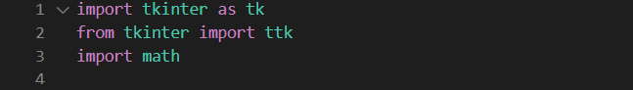Import required library for mathematical manipulation
* 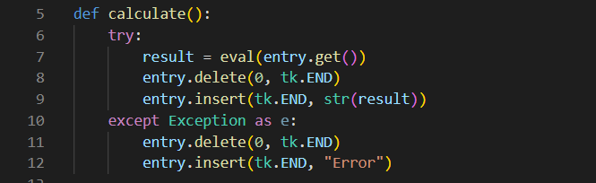Calculates the result, and displays it in the entry widget.

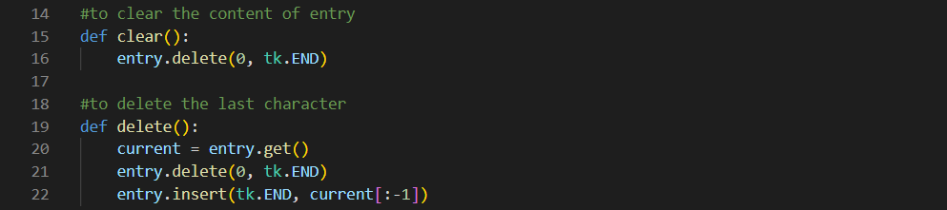

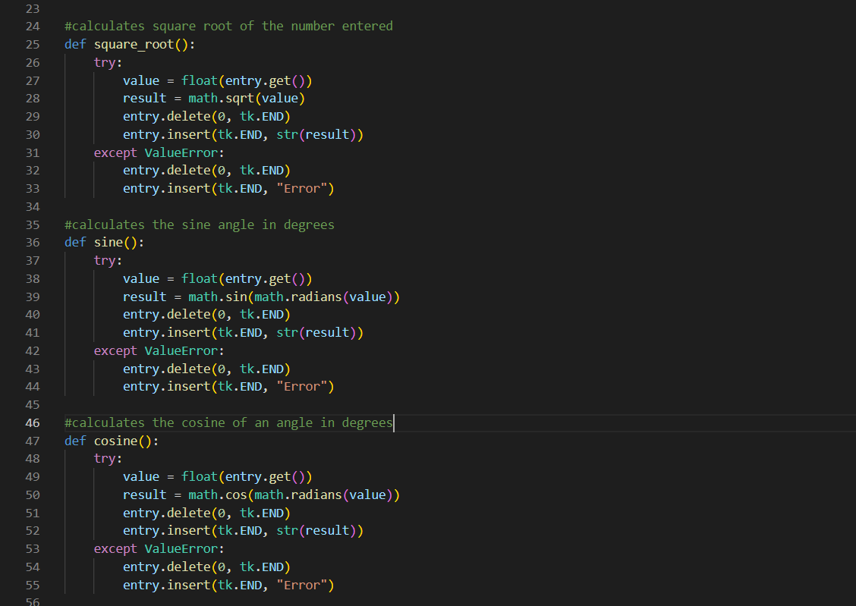

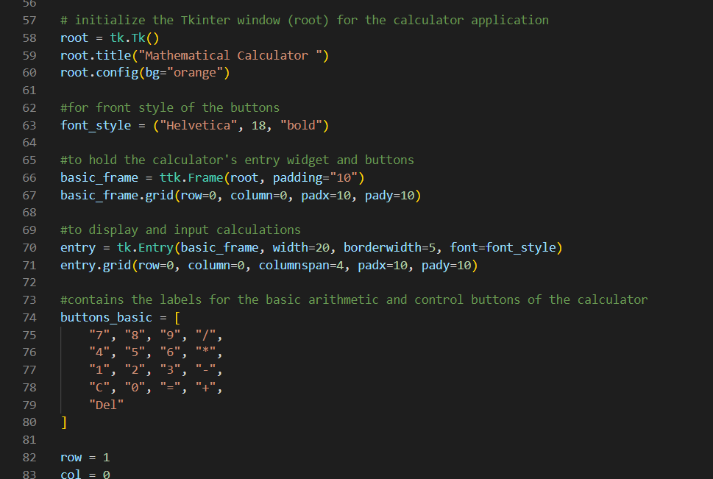

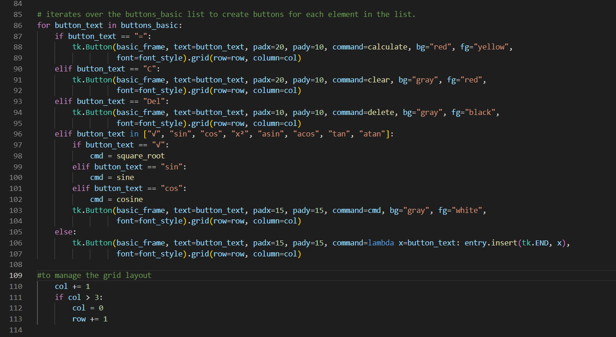

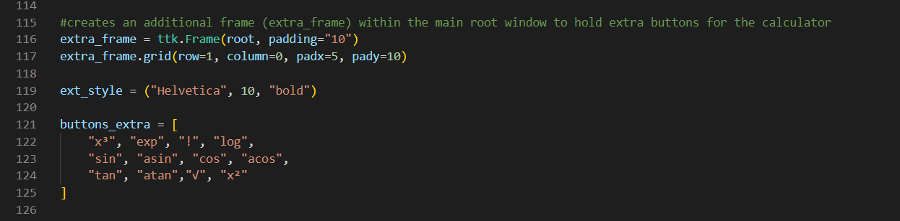

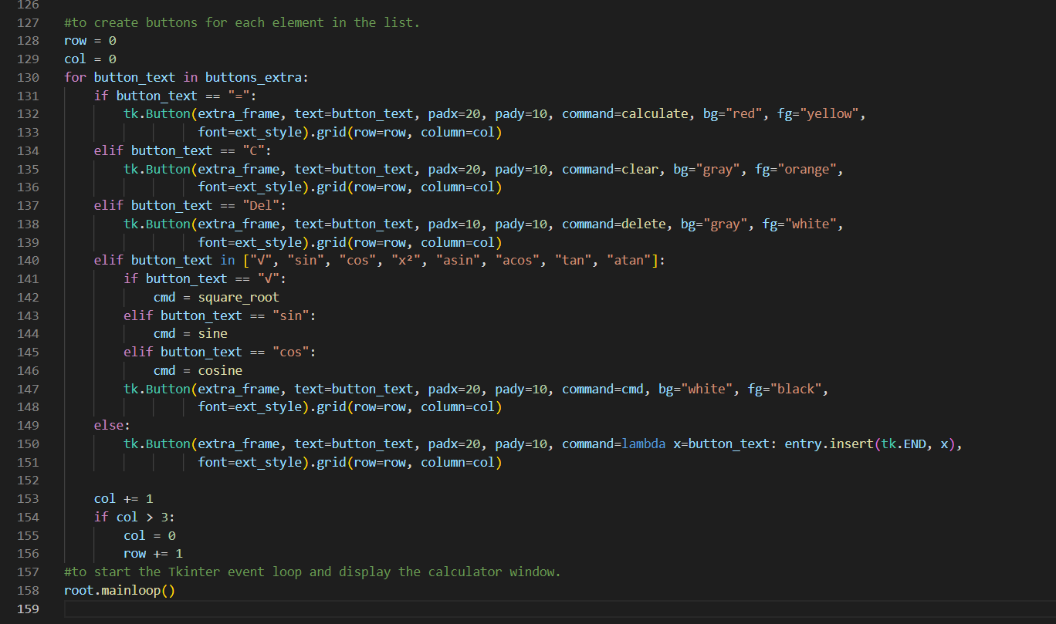

* 1. 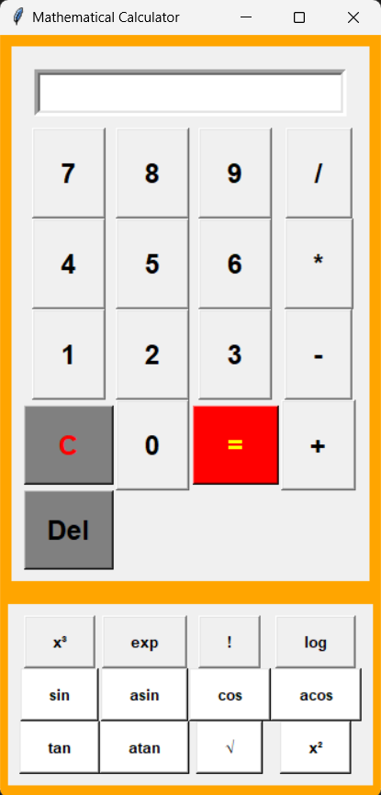**OUTPUT**



